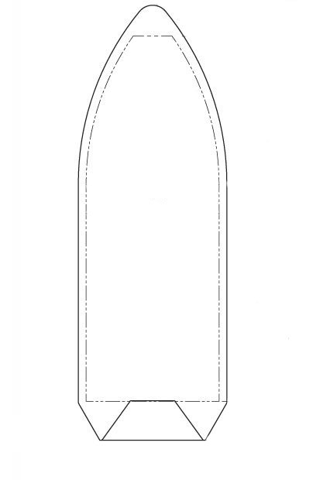

11.4 m

6.6 m

2.5 m

1.3 m

4.6 m